*National University of Science and Technology*

**School of Mechanical and Manufacturing Engineering**

**Assignment #04**

**CS-114 Fundamentals of Programming**

**Course Instructor:** Khawaja Fahad Iqbal

**Lab Instructor:** Muhammad Affan

**Introduction:**

**Name:** Muhammad Furqan Ul Arsh

**CMS ID:** 476347

**Section:** ME-15B

**Date:** 25-10-2023

**Task 1:**

Write a program in C++ that prints the numbers from 1 to 150 except the multiples of 10.

**Solution:**

//Task 1: Program to Print 1-150 numbers except multiples of 10

#include <iostream>

using namespace std;

int main(){

int num;

cout<<"The Numbers From 1 to 150 are: "<<endl;

for(num=0;num<=150;num+=1){ //The Loop Will Run Until It Reaches 150.

if(num%10==0){

continue; //In This Way We Can Remove the Multiples of 10.

}

cout<<num<<"\t"; } //It Will Create Space Between the Output.

return 0;}

**Result:**

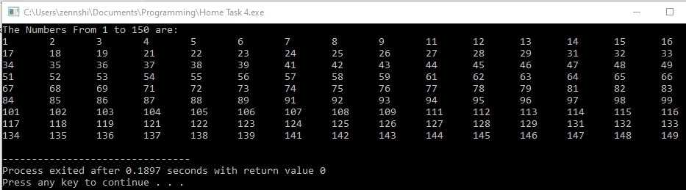

**Task 2:**

Write a C++ program to find the sum of digits of a number.

**Solution:**

//Task 2: Program to Sum the Digits of a Given Number

#include <iostream>

using namespace std;

int main(){

float num,i,a,sum; //Using 4 Variables each for number of digits,digit input,sum of digits and For loop

cout<<"Enter The Number of Digits: "<<endl;

cin>>a;

for(i=1;i<=a;i+=1){ //Following Loop Will Run For The Number Of Digits Entered

cout<<"Enter The Digit No "<<i<<": "<<endl;

cin>>num;

sum+=num; //It Will Add The Number into Sum Variable Everytime The Loop Runs

}

cout<<"The Total Sum of Digits is : "<<sum<<endl; //Finally The Output Will Be Displayed

return 0;}

**Result:**

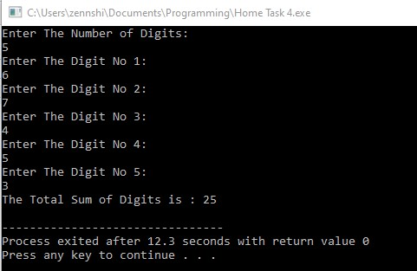

**Task 3:**

Write a program in C++ to check whether a number is prime or not.

**Solution:**

//Task 3 Program to Check if a Given Number is Prime or Not.

#include <iostream>

using namespace std;

int main(){

int num,i,a=0;

cout<<"Input The Number: ";

cin>>num;

for (i=1;i<=num;i+=1){ //The Loop will Run till the number (num) is reached.

if (num%i==0){

a+=1; //If Loop Becomes True, the variable a is incremented.

}

}

if (a==2){ //If a is Incremented Twice, First By 1 And 2nd Time by the Number Itself.

//Then The Number is a Prime Number.

cout<<"The Given Number "<<num<<" is a Prime number."<<endl;

}

else{ //Otherwise Number is Not a Prime Number.

cout<<"The Given Number "<<num<<" is not a Prime number."<<endl;

}

return 0;

}

**Result:**

